 | 7.1.12 Editors - 3D Viewport - Header - Mesh - Edit mode - Face menu
Table of content
Detailed Table of content 1
Edit Mode - Faces menu 4
Legacy 4
Poke Faces 6
Triangulate Faces 7
Triangles to Quads 7
Solidify Faces 8
Wire Frame 9
Fill 9
Grid Fill 10
Beautify Faces 10
Intersect (Knife) 10
Intersect ( Boolean ) 11
Weld Edges into Faces 13
Face Data 13

Detailed Table of content

Detailed table of content
Detailed Table of content 1
Edit Mode - Faces menu 4
Legacy 4
Inset Faces 4
Last Operator Inset Faces 4
Boundary 4
Offset Even 5
Offset Relative 5
Edge Rail 5
Thickness 5
Depth 5
Outset 5
Select Outer 5
Individual 5
Interpolate 5
Bridge Faces 5
Last Operator Bridge Edge loops 5
Connect Loops 6
Merge 6
Merge Factor 6
Twist 6
Number of Cuts 6
Interpolation 6
Smoothness 6
Profile Factor 6
Profile shape 6
Poke Faces 6
Last Operator Poke Faces 6
Poke Offset 6
Offset Relative 6
Poke Center 7
Triangulate Faces 7
Last Operator Triangulate Faces 7
Quad Method 7
Shortest diagonal 7
Fixed Alternate 7
Fixed 7
Beauty 7
Polygon Method 7
Clip 7
Beauty 7
Triangles to Quads 7
Last Operator Tris to Quads 8
Max Face Angle 8
Max Shape Angle 8
Topology influence 8
Compare UV's 8
Compare Color attributes 8
Compare Seam 8
Compare Sharp 8
Compare Materials 8
Deselect Joined 8
Solidify Faces 8
Last Operator Solidify 8
Thickness 8
Wire Frame 9
Last Operator Wire Frame 9
Boundary 9
Offset Even 9
Offset Relative 9
Replace 9
Thickness 9
Offset 9
Crease 9
Crease Weight 9
Fill 9
Last Operator Fill 9
Beauty 9
Grid Fill 10
Last Operator Grid Fill 10
Span 10
Offset 10
Simple Blending 10
Beautify Faces 10
Last Operator Beautify Faces 10
Max Angle 10
Intersect (Knife) 10
Last Operator Intersect 11
Source 11
Selected/Unselected 11
Self Intersect 11
Separate Mode 11
All 11
Cut 11
Merge 11
Solver 11
Float 11
Merge Threshold 11
Exact 11
Intersect ( Boolean ) 11
Last Operator Intersect (Boolean) 11
Boolean Operation 11
Intersect 12
Union 12
Difference 12
Solver 12
Float 12
Swap 12
Self intersection 12
Merge Threshold 12
Exact 12
Swap 12
Self intersection 12
Weld Edges into Faces 13
Face Data 13
Rotate Colors 13
Last Operator Rotate Colors 13
Counter Clockwise 13
Reverse Colors 13
Rotate UV's 14
Last Operator Rotate UV's 14
Flip Quad Tesselation 14
Reverse UV's 14
Mark Freestyle Face 14
Clear Freestyle Face 14

Edit Mode - Faces menu

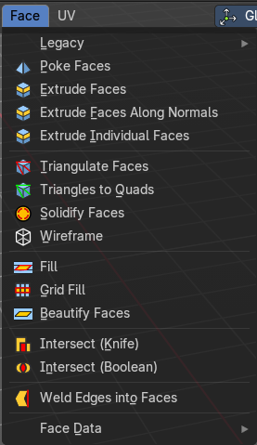
The faces menu is just visible for Mesh objects. It provides tools to work with faces.

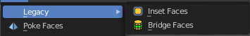
Legacy
The legacy sub menu contains tools that exists in the tool shelf already.
It's the old way to do things. Different to the tools in the tool shelf, these tools are usually modal. And performs once. You have to call them again in case you want to repeat the tool.
Or, in case of the Bridge Faces tool, is a double to another existing tool. The Bridge Faces tool is nothing else than the Bridge Edge Loops tool from the Edge menu. Just with another name, and working in Face selection mode. We promised to provide the same functionality than Blender. And so we have to provide this tool too.

Inset Faces
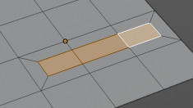
Inset insets edges into the selected faces. Think of it as an extrude inwards the face.
Activate the tool, drag the mouse. But carefully. The control is not the best. You better adjust the amount in the last operator.

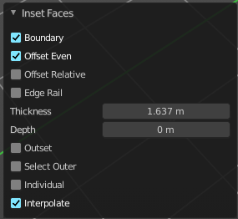
Last Operator Inset Faces

Boundary
With Boundary ticked you will get the connect edges in the corners. Without the edges ends straight.
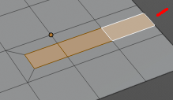

Offset Even
Scales the offset to give more even thickness.

Offset Relative
Scales the offset by surrounding geometry.

Edge Rail
Inset the region along existing edges.

Thickness
Thickness adjusts the thickness of the inset geometry.

Depth
With depth you can bevel the inset geometry. It is then not longer co planar to the initial face.

Outset
With outset ticked the Inset will not extrude inwards but outwards.

Select Outer
With Select Outer the outer ring will be selected after the Inset.

Individual
Inset every face individually.

Interpolate
Blend Face Data across the inset.

Bridge Faces
The Bridge Faces tool bridges selected faces, and adds polygons between them. You need to have at least two faces selected.
This tool is basically the Bridge Edge Loops tool, just that it operates in Face mode.
Note that this tool just shows when you are in Face Select Mode.

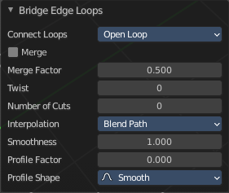
Last Operator Bridge Edge loops

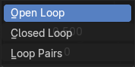
Connect Loops
Choose the method how to deal with bridging multiple loops.

Merge
With merge ticked it will not create a bridge face, but merge the selected edges.

Merge Factor
The merge factor determines at which distance between the selected edges the merge happens. 0.5 is the middle of the selected edges.

Twist
The twist offset for closed loops.

Number of Cuts
Adds cuts to the bridge face.

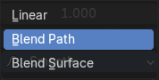
Interpolation
Choose the interpolation mode for the cuts.

Smoothness
Adjust the smoothness for the cuts.

Profile Factor
Adjust the profile factor for the cuts.

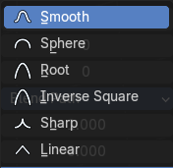
Profile shape
Adjust the profile shape for the cuts.

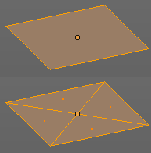
Poke Faces
Splits the selected faces to create a triangulated geometry.

Last Operator Poke Faces

Poke Offset
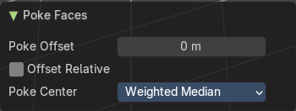
Normally the center vertice of the poke operation is planar with the rest. Adjust an offset.

Offset Relative
Scale the offset by surrounding geometry.
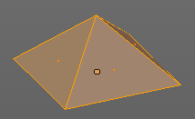

Poke Center
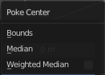
Poke Center is a drop-down box choose what the center of the poke operation should be. You can choose between weighted mean, mean and bounds.

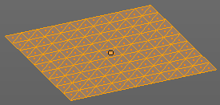
Triangulate Faces
Triangulate Faces triangulates the faces of the selected geometry.

Last Operator Triangulate Faces

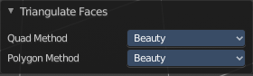
Quad Method
Choose how quads should be triangulated.

Shortest diagonal
Splits the quads based on their distance between vertices.

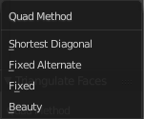
Fixed Alternate
Splits the quads on the second and fourth vertice.

Fixed
Splits the quads on the first and third vertice.

Beauty
Tries to optimize the triangulation.

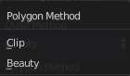
Polygon Method
Choose how N-Gons should be triangulated.

Clip
Splits the polygons with an ear clipping algorithm.

Beauty
Tries to optimize the triangulation.

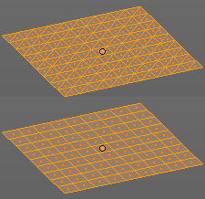
Triangles to Quads
Tris to quads tries to convert triangulated geometry back to a quad geometry by removing the edges inside of the quads.

Last Operator Tris to Quads

Max Face Angle
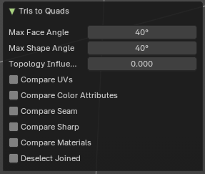
Adjust the threshold to adjacent triangles.

Max Shape Angle
Adjust the shape angle limit.

Topology influence
How much to priorize regular grids of qads as well as quads that touch existing quads.

Compare UV's
Takes the UV patches for the calculation into account. Border geometry will not be calculated.

Compare Color attributes
Takes the Vertex colors for the calculation into account. Border geometry will not be calculated.

Compare Seam
Takes the Vertex colors for the calculation into account. Border geometry will not be calculated.

Compare Sharp
Takes the as sharp marked edges for the calculation into account. Border geometry will not be calculated.

Compare Materials
Takes the Materials colors for the calculation into account. Border geometry will not be calculated.

Deselect Joined
Only select remaining triangles that were not merged.

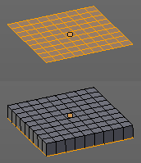
Solidify Faces
Gives the selected faces a thickness, and makes it solid.
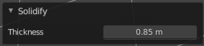
There is also a Solidify modifier available.

Last Operator Solidify

Thickness
Adjust the thickness. You can scale also into the negative range.

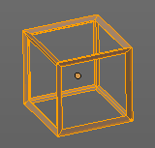
Wire Frame
Wire frame grabs the edges of the faces and turns them into tubes.

Last Operator Wire Frame

Boundary
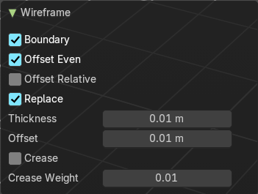
Inset Face Boundaries.

Offset Even
Scales the offset to give more even thickness.

Offset Relative
Scales the offset by surrounding geometry.

Replace
Removes the source geometry.

Thickness
Adjust he thickness of the tubes.

Offset
Adjust the offset of the tubes.

Crease
Crease adds close edges so that you have sharp corners when you use Subdivision Surface.

Crease Weight
Adjust the crease weight.

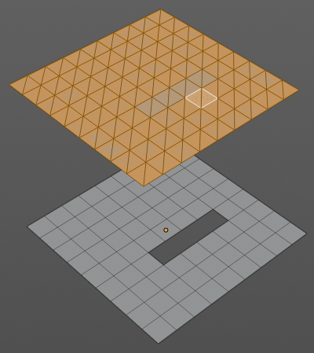
Fill
Fill closes holes in the selected mesh geometry, and triangulates the faces.

Last Operator Fill

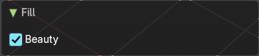
Beauty
Uses the best possible triangulation.

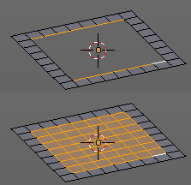
Grid Fill
Grid Fill allows you to fill two edge loops with quad geometry that follows the surrounding geometry.
Usage: select two opposite edge loops. Then perform the tool.

Last Operator Grid Fill

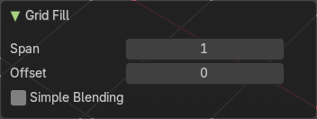
Span
Number of sides.

Offset
Define an offset

Simple Blending
Uses a simple interpolation. Faster but less accurate.

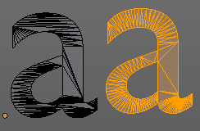
Beautify Faces
Beautify faces tries to optimize triangulation.

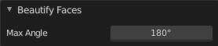
Last Operator Beautify Faces

Max Angle
Set an angle limit.

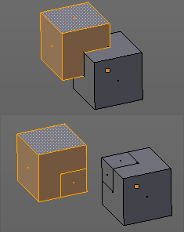
Intersect (Knife)
Intersect creates edges where geometry intersects.
This operation happens in Edit mode, and so all parts must be in the same mesh.

Last Operator Intersect

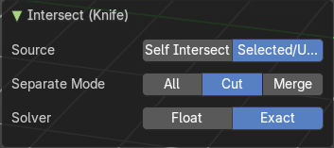
Source

Selected/Unselected
works between the selected and unselected geometry.

Self Intersect
works on the overlapping geometry of the mesh.

Separate Mode

All
Splits the geometry at the new edge.

Cut
keeps each side of the intersection separate without splitting the faces in half.

Merge
Merge all geometry from the intersection.
Merge merges all the geometry from the intersection.

Solver

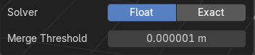
Float

Merge Threshold
Adjust the merge threshold. Increase it when some geometry is not calculated. But keep it small for fast calculation.

Exact
Slower solver with best result for coplanar faces.

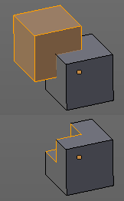
Intersect ( Boolean )
Intersect (Boolean) performs a Boolean operation between the selected and unselected mesh parts.
This operation happens in Edit mode, and so all parts must be in the same mesh.

Last Operator Intersect (Boolean)

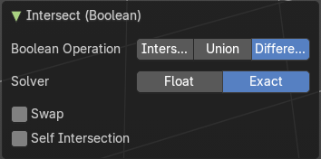
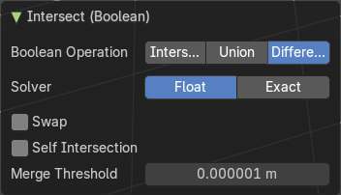
Boolean Operation
Choose the Boolean method.

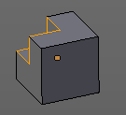
Intersect
Subtracts the source geometry from the target geometry.

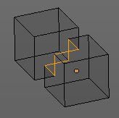
Union
Unions the source geometry with the target geometry. Geometry inside the source and target geometry gets removed.

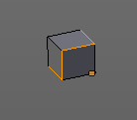
Difference
Removes all geometry but the overlapping geometry.

Solver

Float

Swap
Inverts source and target geometry.

Self intersection
Enable self union / self intersection.

Merge Threshold
Adjust the tolerance for the Boolean operation. Increase it when some geometry is not calculated. But keep it small for fast calculation.

Exact

Swap
Inverts source and target geometry.

Self intersection
Enable self union / self intersection.

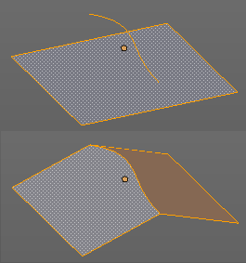
Weld Edges into Faces
This tool incorporates loose wire edges into selected faces.
You need a loose edge geometry to get it to work. By converting a curve to a Mesh geometry for example. You need to join the edge into the mesh where you want to use it. The operation happens in Edit mode.
In edit mode select the edge and the face where you want it to join. And then perform the tool.

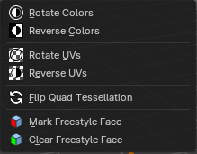
Face Data

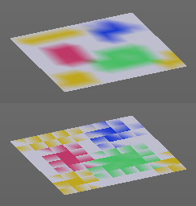
Rotate Colors
Rotates the vertex colors for the selected geometry. This tool requires to have vertex colors painted at the mesh.
Note that there is no way to display vertex colors in Edit mode. So you need to switch to Vertex paint mode to see the result.

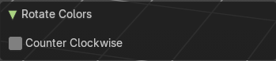
Last Operator Rotate Colors

Counter Clockwise
The tool rotates clockwise by default. With this option ticked the rotation happens counter clockwise.

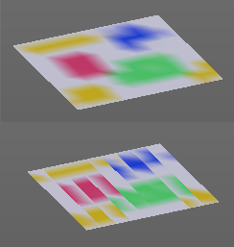
Reverse Colors
Reverses the vertex colors.
Note that there is no way to display vertex colors in Edit mode. So you need to switch to Vertex paint mode to see the result.

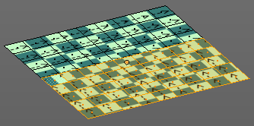
Rotate UV's
Rotates the UV space for the selected geometry by 90 degrees. This tool requires to have a working UV mapping.

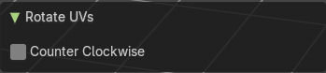
Last Operator Rotate UV's
The tool rotates clockwise by default. With this option ticked the rotation happens counter clockwise.

Flip Quad Tesselation
Flips the tesselation of the selected quads.

Reverse UV's
Reverses the UV Space for the selected geometry. This tool requires to have a working UV mapping.

Mark Freestyle Face
Mark selected Faces for exclusion from Freestyle Feature edge detection. Freestyle is a cartoon renderer that is also included in Bforartists.

Clear Freestyle Face
Unmark selected Faces for exclusion from Freestyle Feature edge detection. Freestyle is a cartoon renderer that is also included in Bforartists.

